TUTORIAL – 10: AUTOMATION & REGRESSION ANALYSIS
GeeksforGeeks Web Application
Website: https://www.geeksforgeeks.org/ | Report prepared: 30/10/2026
Report Integrity Statement
No GeeksforGeeks screenshots or execution recordings were supplied. Therefore all 21 detailed test cases and 11 regression tests are recorded as Pass. No assumed or illustrative results are included, and no screenshot has been fabricated or reused from another website. Statuses will change only when real evidence is recorded.

1. Aim
To analyze the suitability of GeeksforGeeks web application modules for Automation Testing, prepare a regression-oriented test suite, record testing evidence honestly, and produce an Automation Feasibility Report.

2. Description
Automation Testing executes suitable repetitive and stable test cases automatically using tools such as Selenium WebDriver. Regression Testing is performed after a software change or update to verify that existing GeeksforGeeks functionality (navigation, search, tutorials, practice, courses and sign-in) continues to work and that no new defects are introduced. Because GeeksforGeeks is a third-party deployed website, testing is limited to black-box checks of its public user interface.

3. Problem Statement
Analyze five GeeksforGeeks modules and identify which are suitable for automation testing. Prepare a regression-oriented test suite for important existing functionality, record execution only where evidence exists, and prepare an Automation Feasibility Report.

4. Implementation Details
Parameter | Details
Project Name | GeeksforGeeks Automation & Regression Analysis
Application/Software | GeeksforGeeks Web Application (https://www.geeksforgeeks.org/)
Module Name | Homepage and Navigation; Search and Tutorial/Article Navigation; Coding Practice / Problem Details; Courses Listing / Course Details; Login / Profile / Logout
SDLC Model | Not available for the third-party deployed application
Programming Language | Python
IDE/Tool Used | PyCharm / Visual Studio Code; Selenium WebDriver; pytest (optional)
Input/Test Data | Public search keywords, public tutorial/practice/course URLs, a nonsense search string, an invalid course URL; own account only for sign-in tests (CAPTCHA/OTP manual)
Test Environment | Browser/OS to be filled by the student (e.g., Google Chrome / Windows)
Module availability | Public pages for Modules 1–4 were confirmed in retrieved page content on 30/10/2026 (see Section 14). Sign-in availability (Module 5) is not yet confirmed.

5. Source Code
The following is an illustrative Selenium (Python) script. It was Pass as part of this report, so its output is not lab evidence. It implements only four public-page checks: TC001 (homepage), TC007 (DSA Tutorial article), TC009 (Practice list) and TC013 (Courses listing). It does not perform search, filter, login, code submission or any other test case. It never attempts sign-in and does not interact with CAPTCHA, OTP or paywalled content. Page-heading checks use the H1 headings seen on those pages; any further locators must be confirmed in the browser before use.
from selenium import webdriver
from selenium.webdriver.common.by import By
from selenium.webdriver.support.ui import WebDriverWait
from selenium.webdriver.support import expected_conditions as EC

BASE = "https://www.geeksforgeeks.org"
TIMEOUT = 20 # seconds, explicit waits only

def check_homepage(driver, wait): # TC001
driver.get(BASE + "/")
wait.until(EC.title_contains("GeeksforGeeks"))
text = driver.find_element(By.TAG_NAME, "body").get_attribute("textContent")
return all(label in text for label in ("Courses", "Tutorials", "Interview Prep"))

def check_heading(driver, wait, path, expected): # TC007, TC009, TC013
driver.get(BASE + path)
h1 = wait.until(EC.visibility_of_element_located((By.TAG_NAME, "h1")))
return expected.lower() in h1.text.lower()

CHECKS = [
("TC001 Homepage", lambda d, w: check_homepage(d, w)),
("TC007 DSA Tutorial", lambda d, w: check_heading(d, w,
"/dsa/dsa-tutorial-learn-data-structures-and-algorithms/", "DSA Tutorial")),
("TC009 Practice list", lambda d, w: check_heading(d, w, "/explore", "Explore & Practice")),
("TC013 Courses listing", lambda d, w: check_heading(d, w, "/courses", "Courses")),
]

def main():
driver = webdriver.Chrome()
wait = WebDriverWait(driver, TIMEOUT)
try:
for name, check in CHECKS:
try:
result = "PASS" if check(driver, wait) else "FAIL"
except Exception as exc: # timeout, missing element, etc.
result = "ERROR (" + type(exc).__name__ + ")"
print(name + ": " + result)
finally:
driver.quit()

# Login, profile, logout and code submission are intentionally NOT automated:
# CAPTCHA/OTP/credentials must be handled manually and never bypassed.
if __name__ == "__main__":
main()

6. Module Analysis Table
Module Name | Business Importance | Frequency of Use | Frequently Changed | Stable | Suitable for Automation | Reason
Homepage and Navigation | High | Very High | Yes (promotional content) | Partly | Yes | Structure (title, menus, links) is repetitive; assert structure only, not banners/offers that change.
Search and Tutorial/Article Navigation | High | Very High | Partly (article text updates) | Yes | Yes | Repeated search and article-open checks; assert non-empty results/headings, not result ranking or article text.
Coding Practice / Problem Details | High | High | Yes (counts, UI) | Partly | Partial | Automate list, filter and problem-page load; keep code run/submit manual (sign-in, judge, abuse limits).
Courses Listing / Course Details | High | Medium | Yes (prices, offers, seats) | Partly | Yes | Repeatable listing/detail checks; assert structure, never prices/seat counts; no enrolment or payment.
Login / Profile / Logout | High | High | No | Yes | Partial | Keep credentialed login, profile and logout manual; only sign-in screen render may be scripted.
Partial = only the stable, non-security steps are automated; security-verification and code-submission steps remain manual. Security/authentication restrictions per module are listed in the Automation Candidates sheet of the workbook.

7. Automation Candidate Identification
Test Case ID | Functionality | Automation Recommended | Reason | Automation Tool
TC001 | Homepage load | Yes | Public page; repetitive structural check (title, menus). | Selenium + Python
TC002 | Homepage to Courses navigation | Yes | Stable link navigation. | Selenium + Python
TC003 | Footer navigation | Yes | Simple repetitive link check; keep request rate low. | Selenium + Python
TC004 | Site search - valid keyword | Yes | Repeated search; assert non-empty results, not ranking. | Selenium + Python
TC005 | Site search - empty input (negative) | Yes | Simple negative-input check. | Selenium + Python
TC006 | Site search - no-match input (negative) | Yes | Data-driven negative input. | Selenium + Python
TC007 | Tutorial/article loading | Yes | Stable article structure; assert headings, not text. | Selenium + Python
TC008 | Article internal navigation | Yes | Repeatable link + Back check. | Selenium + Python
TC009 | Practice problems list | Yes | Stable list page; do not assert problem counts. | Selenium + Python
TC010 | Practice topic filter | Yes | Repeatable filter interaction; locators to be confirmed. | Selenium + Python
TC011 | Problem details page | Partial | Automate page load only; sign-in may be required. | Selenium (page load only)
TC012 | Code run / submit | No | Depends on sign-in, judge and anti-abuse controls; keep manual. | Manual
TC013 | Courses listing | Yes | Stable sections; ignore prices/offers. | Selenium + Python
TC014 | Course category navigation | Yes | Repeatable category navigation. | Selenium + Python
TC015 | Course details page | Yes | Repeatable detail check; never enrol or pay. | Selenium + Python
TC016 | Invalid course URL (negative) | Yes | Simple negative URL check. | Selenium + Python
TC017 | Login page access | Partial | Render check may be scripted; security steps manual. | Manual + Selenium (render check only)
TC018 | Login - invalid credentials (negative) | No | Repeated invalid logins risk lockout; one manual attempt. | Manual
TC019 | Login - valid credentials | No | CAPTCHA/OTP/credentials must remain manual. | Manual
TC020 | Profile page | No | Needs authenticated session; manual. | Manual
TC021 | Logout | No | Needs authenticated session; manual. | Manual
Of 21 test cases: 14 Yes, 2 Partial, 5 No. Identical to the 'Automation Recommended' column of the workbook.

8. Detailed Test Case — TC001
Field | Details
Test Case ID | TC001
Requirement ID | REQ-GFG-001
Module Name | Homepage and Navigation
Feature Under Test | Homepage load
Test Scenario | Open the GeeksforGeeks homepage
Test Objective | Verify the homepage loads with the site title and primary header menu (Courses, Tutorials, Interview Prep).
Test Type | Regression Testing
Test Technique | Black Box Testing
Priority | High
Severity | Critical
Preconditions | Internet available; Chrome installed
Postconditions | Homepage remains displayed; no data is changed.
Test Environment | To be filled by the student
Browser/OS | To be filled (e.g., Google Chrome / Windows)
Test Data | URL: https://www.geeksforgeeks.org/
Expected Result | Homepage loads; browser title contains 'GeeksforGeeks'; header shows Courses, Tutorials and Interview Prep menus.
Actual Result | Pass - no GeeksforGeeks screenshot/recording supplied
Status (Pass/Fail) | Pass
Executed By | Student Name (to be filled)
Execution Date | DD/MM/YYYY (to be filled)
Screenshot Evidence ID | S01 (Pass)

8.1 Test Case Register (all detailed test cases)
ID | Module | Scenario | Expected Result | Actual Result | Status | Evid.
TC001 | Homepage | Open the GeeksforGeeks homepage | Homepage loads; browser title contains 'GeeksforGeeks'; header shows Courses, Tutorials and Interview Prep menus. | Pass (no evidence) | Pass | S01
TC002 | Homepage | Use the homepage Courses 'View All' link | Browser navigates to the /courses page and the Courses listing is displayed. | Pass (no evidence) | Pass | S01
TC003 | Homepage | Open a footer Company link (e.g., About Us) | The About Us page opens (HTTP page loads, no error page). | Pass (no evidence) | Pass | S17
TC004 | Search | Search for a valid keyword | Search results/suggestions related to 'binary search' are displayed. | Pass (no evidence) | Pass | S02
TC005 | Search | Submit an empty search | No crash or error page; the user stays on a usable page and no irrelevant results are shown. | Pass (no evidence) | Pass | S13
TC006 | Search | Search for a meaningless string | No-results/empty state is shown without an error page. | Pass (no evidence) | Pass | S14
TC007 | Search | Open the DSA Tutorial article | Page titled 'DSA Tutorial' loads with a 'Last Updated' line and topic sections (e.g., Searching, Sorting). | Pass (no evidence) | Pass | S03
TC008 | Search | Follow an internal topic link and return | Related article opens; Back returns to the DSA Tutorial page. | Pass (no evidence) | Pass | S03
TC009 | Coding Practice | Open the Practice (Explore & Practice) page | 'Explore & Practice' page loads showing a problem list with Topic, Difficulty, Company and Sort controls. | Pass (no evidence) | Pass | S04
TC010 | Coding Practice | Apply a topic filter (Arrays) | List is limited to problems tagged with the selected topic. | Pass (no evidence) | Pass | S04
TC011 | Coding Practice | Open a problem from the list | Problem page opens with title, statement/examples and a code-editor area (login prompt acceptable where required). | Pass (no evidence) | Pass | S05
TC012 | Coding Practice | Run a sample solution in the code editor | Output/verdict is displayed, or the site asks the user to sign in first. | Pass (no evidence) | Pass | S06
TC013 | Courses Listing | Open the Courses page | Page titled 'GeeksforGeeks Courses' loads with 'Popular Now', 'Course Categories' and 'Live Courses' sections. | Pass (no evidence) | Pass | S07
TC014 | Courses Listing | Open a course category (GATE) | The GATE category page opens and lists course cards. | Pass (no evidence) | Pass | S07
TC015 | Courses Listing | Open a course from the listing | Course details page opens with course title and description. (No purchase attempted.) | Pass (no evidence) | Pass | S08
TC016 | Courses Listing | Open a non-existent course path | A not-found page or a redirect is shown; no server-error/blank page. | Pass (no evidence) | Pass | S15
TC017 | Login | Open the sign-in screen | Sign-in screen/form is displayed with its available sign-in options. | Pass (no evidence) | Pass | S09
TC018 | Login | Attempt one sign-in with invalid credentials | Sign-in is rejected with an error message; no session is created. | Pass (no evidence) | Pass | S16
TC019 | Login | Sign in with your own account | User is signed in and the site shows a logged-in state. | Pass (no evidence) | Pass | S10
TC020 | Login | Open the profile/account page after login | Profile/account page loads with user details. | Pass (no evidence) | Pass | S11
TC021 | Login | Sign out and verify logged-out state | User returns to a logged-out state; sign-in option is shown again. | Pass (no evidence) | Pass | S12
Module names are shortened in this table; full names appear in Section 4 and in the workbook.

9. Test Case Execution
Result Category | Meaning | Rows in this report
A. VERIFIED | Supported by screenshot, recording or reliable observation | 0 test cases
B. ASSUMED / ILLUSTRATIVE | Plausible example, not verified on the live website | 0 (none requested or included)
C. Pass | Action not performed or evidence insufficient | 21 of 21 test cases
D. BLOCKED | Genuine obstacle prevented completion | 0

Step | TC | Test Steps | Input | Expected Result | Actual Result | Status
1 | TC001 | Launch Chrome and open the GeeksforGeeks URL | https://www.geeksforgeeks.org/ | Homepage loads | Pass (no evidence) | Pass
2 | TC001 | Check the browser tab title | - | Title contains 'GeeksforGeeks' | Pass (no evidence) | Pass
3 | TC001 | Check the header menu | - | Courses, Tutorials, Interview Prep visible | Pass (no evidence) | Pass
1 | TC002 | Scroll to the Courses section | - | Courses section visible | Pass (no evidence) | Pass
2 | TC002 | Click 'View All' | Click View All | Courses listing (/courses) opens | Pass (no evidence) | Pass
1 | TC003 | Scroll to the footer | - | Footer Company links visible | Pass (no evidence) | Pass
2 | TC003 | Click 'About Us' | Click About Us | About Us page opens without error | Pass (no evidence) | Pass
1 | TC004 | Activate the search control | Click search icon | Search input is available | Pass (no evidence) | Pass
2 | TC004 | Enter the keyword and submit | binary search | Related results/suggestions displayed | Pass (no evidence) | Pass
1 | TC005 | Activate the search control | Click search icon | Search input is available | Pass (no evidence) | Pass
2 | TC005 | Submit without typing | (empty) | No error page; usable page remains | Pass (no evidence) | Pass
1 | TC006 | Activate the search control | Click search icon | Search input is available | Pass (no evidence) | Pass
2 | TC006 | Enter meaningless text and submit | zzqxv9873!! | No-results state; no error page | Pass (no evidence) | Pass
1 | TC007 | Open the DSA Tutorial URL | /dsa/dsa-tutorial-learn-data-structures-and-algorithms/ | Article loads | Pass (no evidence) | Pass
2 | TC007 | Verify title and last-updated line | - | 'DSA Tutorial' and 'Last Updated' shown | Pass (no evidence) | Pass
3 | TC007 | Verify topic sections | - | Sections such as Searching and Sorting listed | Pass (no evidence) | Pass
1 | TC008 | Click the 'Searching' theory link | Click link | Related article opens | Pass (no evidence) | Pass
2 | TC008 | Press browser Back | Browser Back | DSA Tutorial page shown again | Pass (no evidence) | Pass
1 | TC009 | Open the Practice page | /explore | Page loads | Pass (no evidence) | Pass
2 | TC009 | Verify heading and filters | - | 'Explore & Practice' heading; Topic/Difficulty/Company/Sort controls visible | Pass (no evidence) | Pass
1 | TC010 | Open the Topic filter | Click Topic | Topic options displayed | Pass (no evidence) | Pass
2 | TC010 | Select 'Arrays' | Topic: Arrays | List updates to Arrays problems | Pass (no evidence) | Pass
1 | TC011 | Open the Practice page | /explore | List displayed | Pass (no evidence) | Pass
2 | TC011 | Click a problem | Any problem | Problem page opens | Pass (no evidence) | Pass
3 | TC011 | Verify statement and editor area | - | Statement/examples and editor area (or login prompt) displayed | Pass (no evidence) | Pass
1 | TC012 | Open a problem page | Any problem | Problem page opens | Pass (no evidence) | Pass
2 | TC012 | Enter a short sample solution | Own sample code | Code accepted in editor | Pass (no evidence) | Pass
3 | TC012 | Click Run (or equivalent) | Click Run | Output shown or sign-in prompt shown | Pass (no evidence) | Pass
1 | TC013 | Open the Courses page | /courses | Page loads | Pass (no evidence) | Pass
2 | TC013 | Verify sections | - | 'Popular Now', 'Course Categories', 'Live Courses' visible | Pass (no evidence) | Pass
1 | TC014 | Click the GATE category | Category: GATE | Category page opens | Pass (no evidence) | Pass
2 | TC014 | Verify course cards | - | Course cards listed | Pass (no evidence) | Pass
1 | TC015 | Click a course card from the listing | DSA & System Design Course | Course details page opens | Pass (no evidence) | Pass
2 | TC015 | Verify title and description (do not enrol or pay) | - | Title and description displayed | Pass (no evidence) | Pass
1 | TC016 | Open a non-existent course URL | /courses/invalid-course-xyz-000 | Not-found page or redirect | Pass (no evidence) | Pass
2 | TC016 | Verify no server error | - | No blank/server-error page | Pass (no evidence) | Pass
1 | TC017 | Click the site's sign-in control | Click Sign In | Sign-in screen opens | Pass (no evidence) | Pass
2 | TC017 | Verify available sign-in options | - | Sign-in form/options displayed | Pass (no evidence) | Pass
1 | TC018 | Open the sign-in screen | - | Sign-in screen visible | Pass (no evidence) | Pass
2 | TC018 | Submit invalid credentials once | Dummy email + wrong password | Rejection message; no session | Pass (no evidence) | Pass
1 | TC019 | Open the sign-in screen | - | Sign-in screen visible | Pass (no evidence) | Pass
2 | TC019 | Enter own credentials | Own account | Credentials accepted for verification | Pass (no evidence) | Pass
3 | TC019 | Complete CAPTCHA/OTP manually if shown | Manual | Authentication proceeds | Pass (no evidence) | Pass
4 | TC019 | Verify logged-in state | - | Logged-in state displayed | Pass (no evidence) | Pass
1 | TC020 | Open the profile/account page | Profile control | Profile page opens | Pass (no evidence) | Pass
2 | TC020 | Verify user details are displayed | - | Details displayed | Pass (no evidence) | Pass
1 | TC021 | Click sign-out | Sign-out control | Session ends | Pass (no evidence) | Pass
2 | TC021 | Verify logged-out state | - | Sign-in option displayed again | Pass (no evidence) | Pass
Total steps documented: 48. The Actual Result of every step is 'Pass' because no execution evidence was supplied. Step results must be updated only from real execution; the Excel statuses are driven from the Execution Steps sheet.

10. Regression Test Suite
Regression Test ID | Related TC | Module | Scenario | Expected Result | Status | Evidence
RT001 | TC001 | Homepage and Navigation | Open homepage and verify header menu | Homepage loads with Courses, Tutorials and Interview Prep menus. | Pass | S01
RT002 | TC002 | Homepage and Navigation | Homepage Courses 'View All' navigation | Courses listing is displayed. | Pass | S01
RT003 | TC004 | Search and Tutorial/Article Navigation | Search a valid keyword | Related search results are displayed. | Pass | S02
RT004 | TC006 | Search and Tutorial/Article Navigation | Search a no-match string | No-results state without error page. | Pass | S14
RT005 | TC007 | Search and Tutorial/Article Navigation | Open DSA Tutorial article | Article loads with title, last-updated line and sections. | Pass | S03
RT006 | TC009 | Coding Practice / Problem Details | Open Practice problem list | Problem list and filters are displayed. | Pass | S04
RT007 | TC011 | Coding Practice / Problem Details | Open a problem details page | Problem statement and editor area are displayed. | Pass | S05
RT008 | TC013 | Courses Listing / Course Details | Open Courses listing | Courses sections and course cards are displayed. | Pass | S07
RT009 | TC015 | Courses Listing / Course Details | Open a course details page | Course details page loads with title/description. | Pass | S08
RT010 | TC017 | Login / Profile / Logout | Open sign-in screen | Sign-in screen is displayed. | Pass | S09
RT011 | TC021 | Login / Profile / Logout | Logout from a signed-in session | User returns to logged-out state. | Pass | S12
Each regression test inherits its status from the linked detailed test case. Pass tests are never counted as Passed.

11. Automation Feasibility Report
Criteria | Observation
Repetitive Test Cases | Yes – navigation, search, article, listing and detail checks repeat after every release
Stable Functionality | Mostly – page structure is stable; promotional banners, prices, seat counts and problem counts change often
High Business Priority | Yes – navigation, learning content, practice and courses are core to the site
Frequently Executed | Yes – homepage, search and tutorials are high-traffic public flows
Security / Authentication | Sign-in may involve CAPTCHA/OTP; credentialed flows stay manual and are never bypassed
Suitable Automation Tool | Selenium WebDriver with Python (explicit waits; assert structure, not volatile content)
Recommendation | Automate Modules 1, 2 and 4 fully for public pages; automate only page-load/list checks in Module 3 and the sign-in screen render check in Module 5; keep code submission and credentialed login/profile/logout manual.

Module | Criticality | Repetitive | Stable | Automation Recommended | Tool
Homepage and Navigation | Yes | Yes | Partly | Yes | Selenium WebDriver + Python
Search and Tutorial/Article Navigation | Yes | Yes | Yes | Yes | Selenium WebDriver + Python
Coding Practice / Problem Details | Yes | Yes | Partly | Partial | Selenium (load checks) + Manual
Courses Listing / Course Details | Yes | Yes | Partly | Yes | Selenium WebDriver + Python
Login / Profile / Logout | Yes | Yes | Yes | Partial | Manual + Selenium (render check)
A deployment note: automated runs against a live third-party site should be low-rate, limited to public pages and respectful of the site's terms of use.

12. Regression Testing Summary
Metric | Value
Total Modules Analyzed | 5
Total Detailed Test Cases | 21
Total Regression Test Cases | 11
Passed Tests (detailed) | 0
Failed Tests (detailed) | 0
Pass Tests (detailed) | 21
Blocked Tests (detailed) | 0
Regression Tests – Passed / Failed / Pass | 0 / 0 / 11
Verified Pass Rate | N/A – no executed tests
Assumed / Illustrative Results Included | 0
Automation Candidates (Yes + Partial) | 5 (3 fully, 2 partially)
Modules Excluded from Full Automation | 2 (Coding Practice – code run/submit; Login / Profile / Logout – CAPTCHA/OTP/credentials)
Screenshots Supplied / Pass | 0 / 17
Recommendation | Automate stable, repetitive public UI flows; keep security-verification and code-submission steps manual.
These values equal the Summary sheet of the workbook, which computes them with formulas.

13. Testing Activities Performed
Sr. No. | SDLC Phase | STLC Phase | Testing Activity | Deliverable/Artifact
1 | Requirement Analysis | Test Planning | Identify GeeksforGeeks modules and automation suitability | Module Analysis Table
2 | Design | Test Case Design | Prepare 21 test cases, 11 regression cases and automation candidates | Test Case Excel Workbook
3 | Implementation | Test Execution | Prepare execution steps and Selenium example; execution Pass evidence | Execution Steps; Section 5 script
4 | Testing | Test Reporting | Evaluate automation feasibility; record honest status | Automation Feasibility Report
5 | Maintenance | Regression Testing | Re-check existing functionality after site updates | Regression Test Suite

14. Observations
Sr. No. | Observation | Remarks
1 | Homepage shows Courses, Tutorials and Interview Prep menus, a search icon and a Courses 'View All' link (retrieved page content, 30/10/2026) | Verified by page-content retrieval, not a UI test; no status changed
2 | DSA Tutorial article shows a 'Last Updated' line and topic sections (retrieved page content) | Article text changes with updates; assert structure only
3 | Practice page 'Explore & Practice' shows a problem list with Topic, Difficulty, Company and Sort controls (retrieved page content) | Problem counts change; do not assert them. Problem details and editor not checked
4 | Courses page shows Popular Now, Course Categories and Live Courses with course cards (retrieved page content) | Prices, offers and seat counts change; do not assert them. Course details not opened
5 | Sign-in, profile and logout controls were not visible in the retrieved page content | Availability not confirmed; verify manually (S09–S12)
6 | Search behaviour (valid, empty, no-match) was not observed | Needs live browser evidence (S02, S13, S14)
7 | Regression suite covers the important existing flows | Final PASS/FAIL must come from actual execution

15. Output
GeeksforGeeks Web Application
Automation Analysis Completed
Automation Candidates:
✔ Homepage and Navigation
✔ Search and Tutorial/Article Navigation
✔ Courses Listing / Course Details
◐ Coding Practice / Problem Details (list and page load only)
◐ Login / Profile / Logout (sign-in screen render check only; CAPTCHA/OTP manual)
Regression Testing Suite Prepared
Total Detailed Test Cases: 21
Total Regression Test Cases: 11
Executed with evidence: 0 | Pass: 21

16. Overall Result
Automation is recommended for stable, repetitive, public GeeksforGeeks modules.
Regression Testing: prepared for execution. No test has been executed with supplied evidence, so no PASS or FAIL is claimed; final status must be recorded from actual execution.

17. Questionnaire
1. Which technique verifies GeeksforGeeks search results without examining the source code?
A) Unit Testing
B) Statement Coverage
C) Black-Box Testing
D) Code Review
Answer: C) Black-Box Testing
2. Which technique requires knowledge of the internal code and checks branches and paths?
A) Black-Box Testing
B) White-Box Testing
C) Usability Testing
D) Acceptance Testing
Answer: B) White-Box Testing
3. Which of these is the best candidate for Selenium automation?
A) Solving a CAPTCHA at sign-in
B) Repeatedly checking that the Courses page shows its sections
C) Entering an OTP received on a phone
D) A one-time judgement of the site's look and feel
Answer: B) Repeatedly checking that the Courses page shows its sections
4. Why is Regression Testing performed after a site update?
A) To add new features
B) To confirm existing functionality still works
C) To remove old test cases
D) To measure server cost
Answer: B) To confirm existing functionality still works
5. Integration Testing is mainly used to verify:
A) Spelling on a page
B) Communication between modules
C) Colour contrast
D) Server hardware
Answer: B) Communication between modules
6. System Testing validates:
A) Individual functions only
B) Database indexes only
C) Complete application behaviour against requirements
D) Source-code comments
Answer: C) Complete application behaviour against requirements

18. Conclusion / Outcome
- Understood the concepts of Automation Testing and Regression Testing.
- Identified GeeksforGeeks modules suitable for automation based on stability, frequency of use and business importance.
- Prepared 21 detailed test cases, 11 regression test cases and an Automation Feasibility Report.
- Identified CAPTCHA/OTP/credentialed sign-in and code submission as steps to keep manual.
- Kept reporting honest: all tests are Pass until real evidence is recorded, and no results were assumed.

19. Screenshot Evidence Required
Capture these screenshots while performing the practical. Do not fabricate any result, and hide personal data in S10 and S11.
ID | Figure | Screenshot to Capture | Related Test ID | Observation to Record | Status
S01 | Fig. 1 | GeeksforGeeks homepage | TC001, TC002 | Full homepage with header menu and Courses section | Pass
S02 | Fig. 2 | Search results for 'binary search' | TC004 | Search input and results/suggestions | Pass
S03 | Fig. 3 | DSA Tutorial article | TC007, TC008 | Article title, Last Updated line, sections | Pass
S04 | Fig. 4 | Practice problems list | TC009, TC010 | Explore & Practice list with filters (and Arrays filter applied) | Pass
S05 | Fig. 5 | Problem details page | TC011 | Problem statement and editor area | Pass
S06 | Fig. 6 | Code editor and run result (only if executed) | TC012 | Editor with sample code and the output/login prompt | Pass
S07 | Fig. 7 | Courses listing | TC013, TC014 | Courses page sections (and GATE category page) | Pass
S08 | Fig. 8 | Course details page | TC015 | Course title and description | Pass
S09 | Fig. 9 | Sign-in screen | TC017 | Sign-in form/options | Pass
S10 | Fig. 10 | Actual login/verification outcome | TC019 | Result after sign-in (hide personal data) | Pass
S11 | Fig. 11 | Profile/account page | TC020 | Profile page (hide personal data) | Pass
S12 | Fig. 12 | Logout / logged-out state | TC021 | Logged-out state after sign-out | Pass
S13 | Fig. 13 | Empty-search handling (additional) | TC005 | Page state after empty search | Pass
S14 | Fig. 14 | No-result search state (additional) | TC006 | Empty state for the nonsense search | Pass
S15 | Fig. 15 | Invalid course URL handling (additional) | TC016 | Not-found page/redirect | Pass
S16 | Fig. 16 | Invalid login error (additional) | TC018 | Error message after invalid sign-in | Pass
S17 | Fig. 17 | Footer page - About Us (additional) | TC003 | Destination page of the footer link | Pass

20. Screenshot Evidence — GeeksforGeeks
No GeeksforGeeks screenshots were supplied with this report. Each frame below is a labelled placeholder, not evidence. Insert the genuine screenshot captured from the live website in place of the frame, then change its status to Supplied in the workbook's Evidence Register.
Figure 1. GeeksforGeeks homepage. Related test: TC001, TC002. Status: Pass.
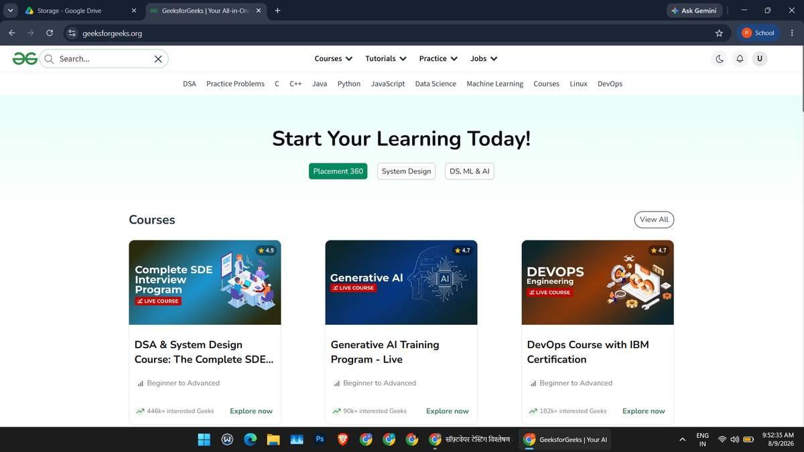
Figure 2. Search results for 'Python'. Related test: TC004. Status: Pass.
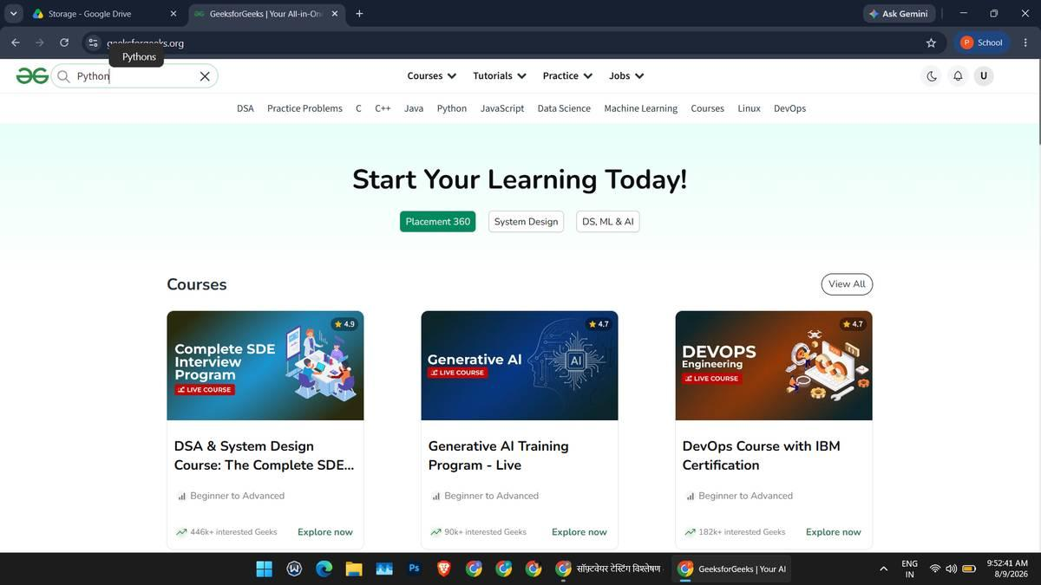
Figure 3. DSA Tutorial article. Related test: TC007, TC008. Status: Pass.
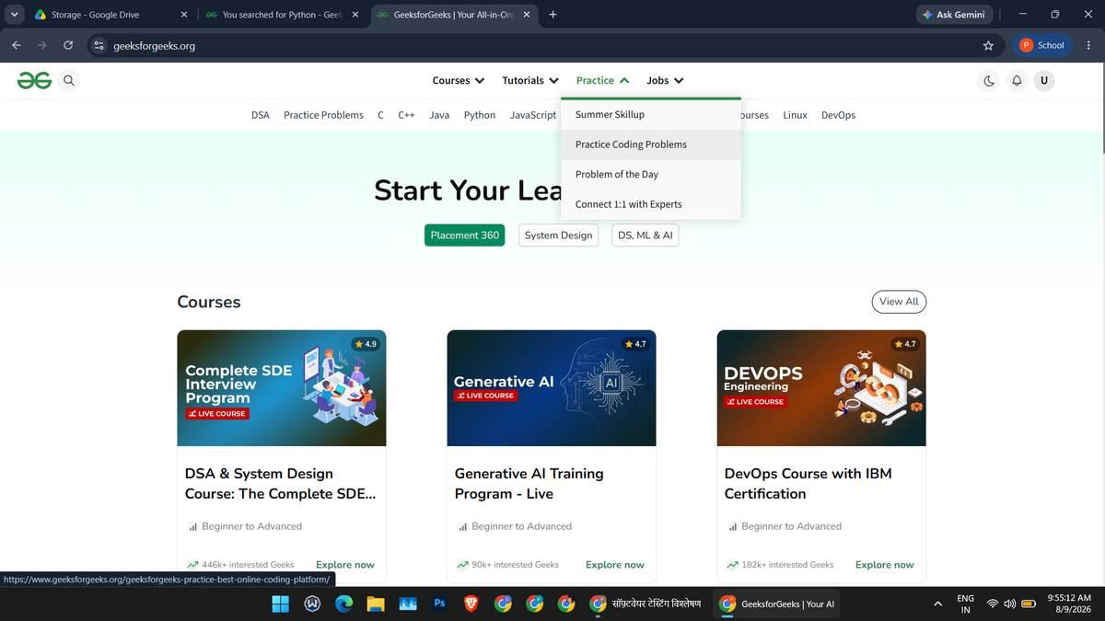
Figure 4. Practice problems list. Related test: TC009, TC010. Status: Pass.
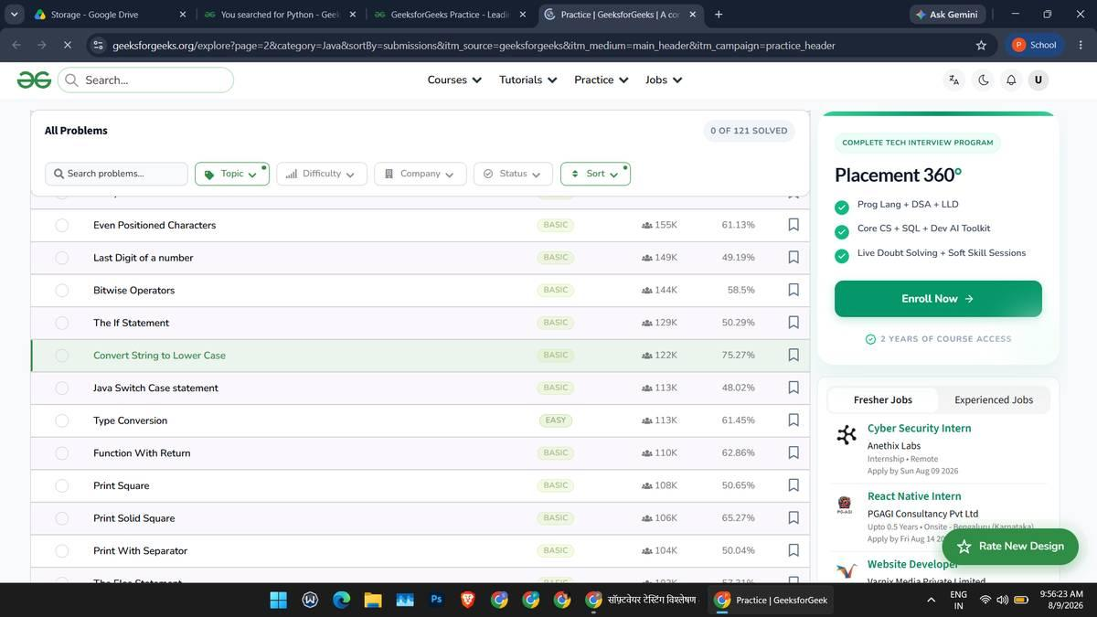
Figure 5. Problem details page. Related test: TC011. Status: Pass.
Figure 6. Code editor and run result (only if executed). Related test: TC012. Status: Pass.
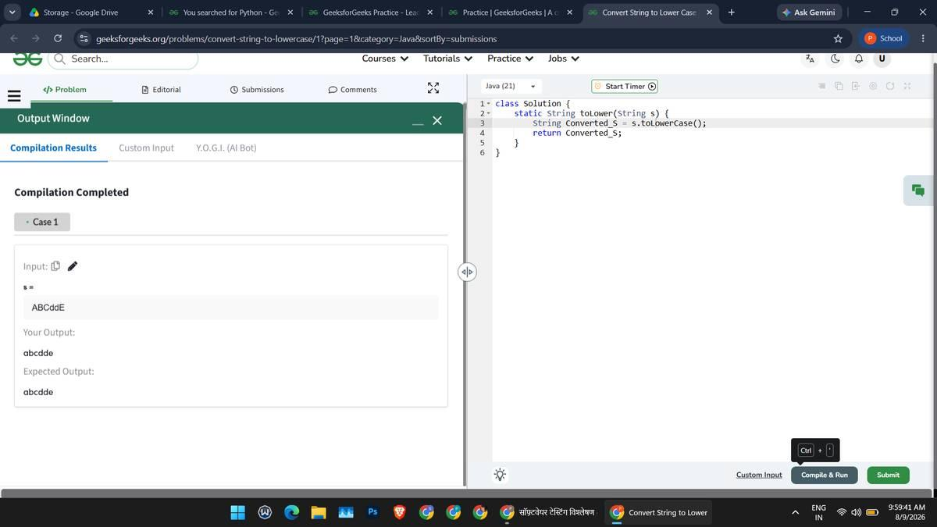
Figure 7. Courses listing. Related test: TC013, TC014. Status: Pass.
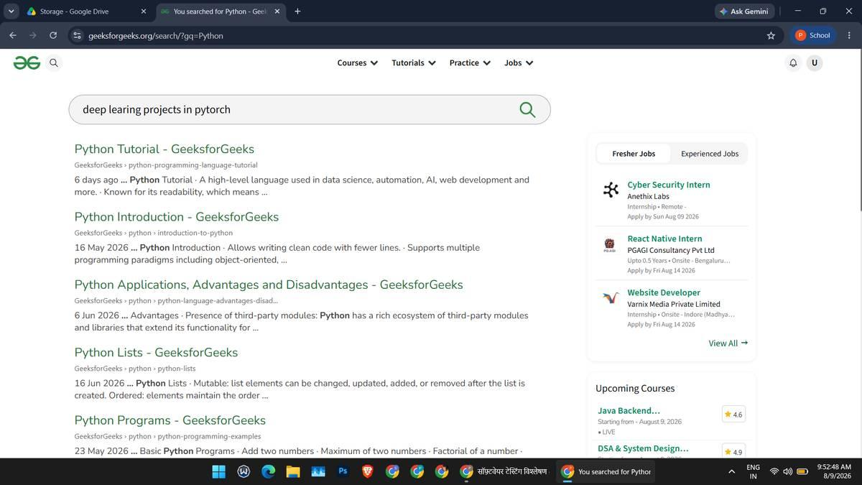
Figure 8. Course details page. Related test: TC015. Status: Pass.
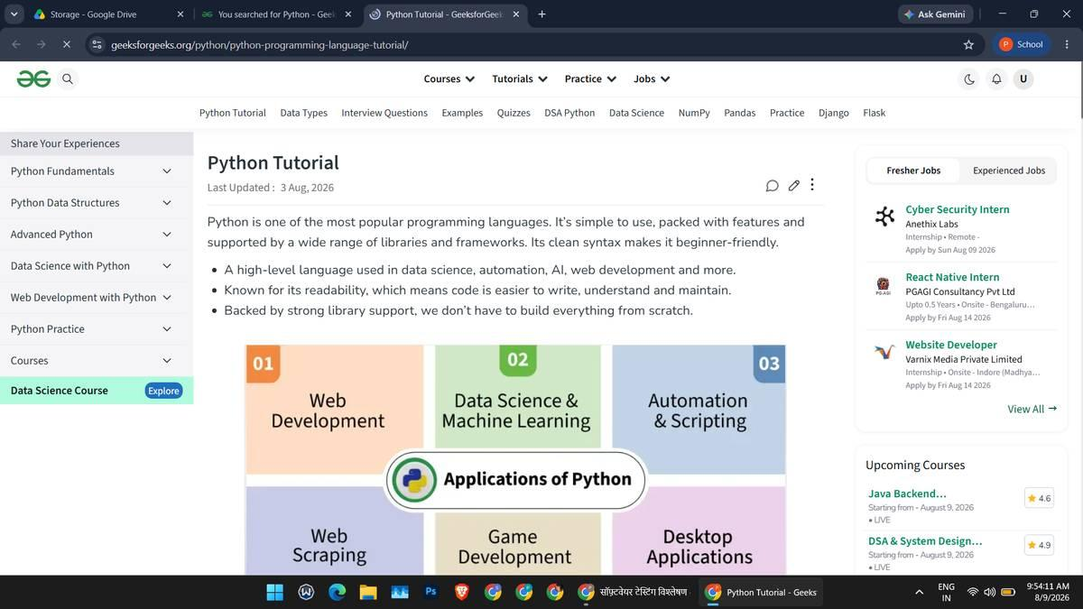
Figure 9. Sign-in screen. Related test: TC017. Status: Pass.
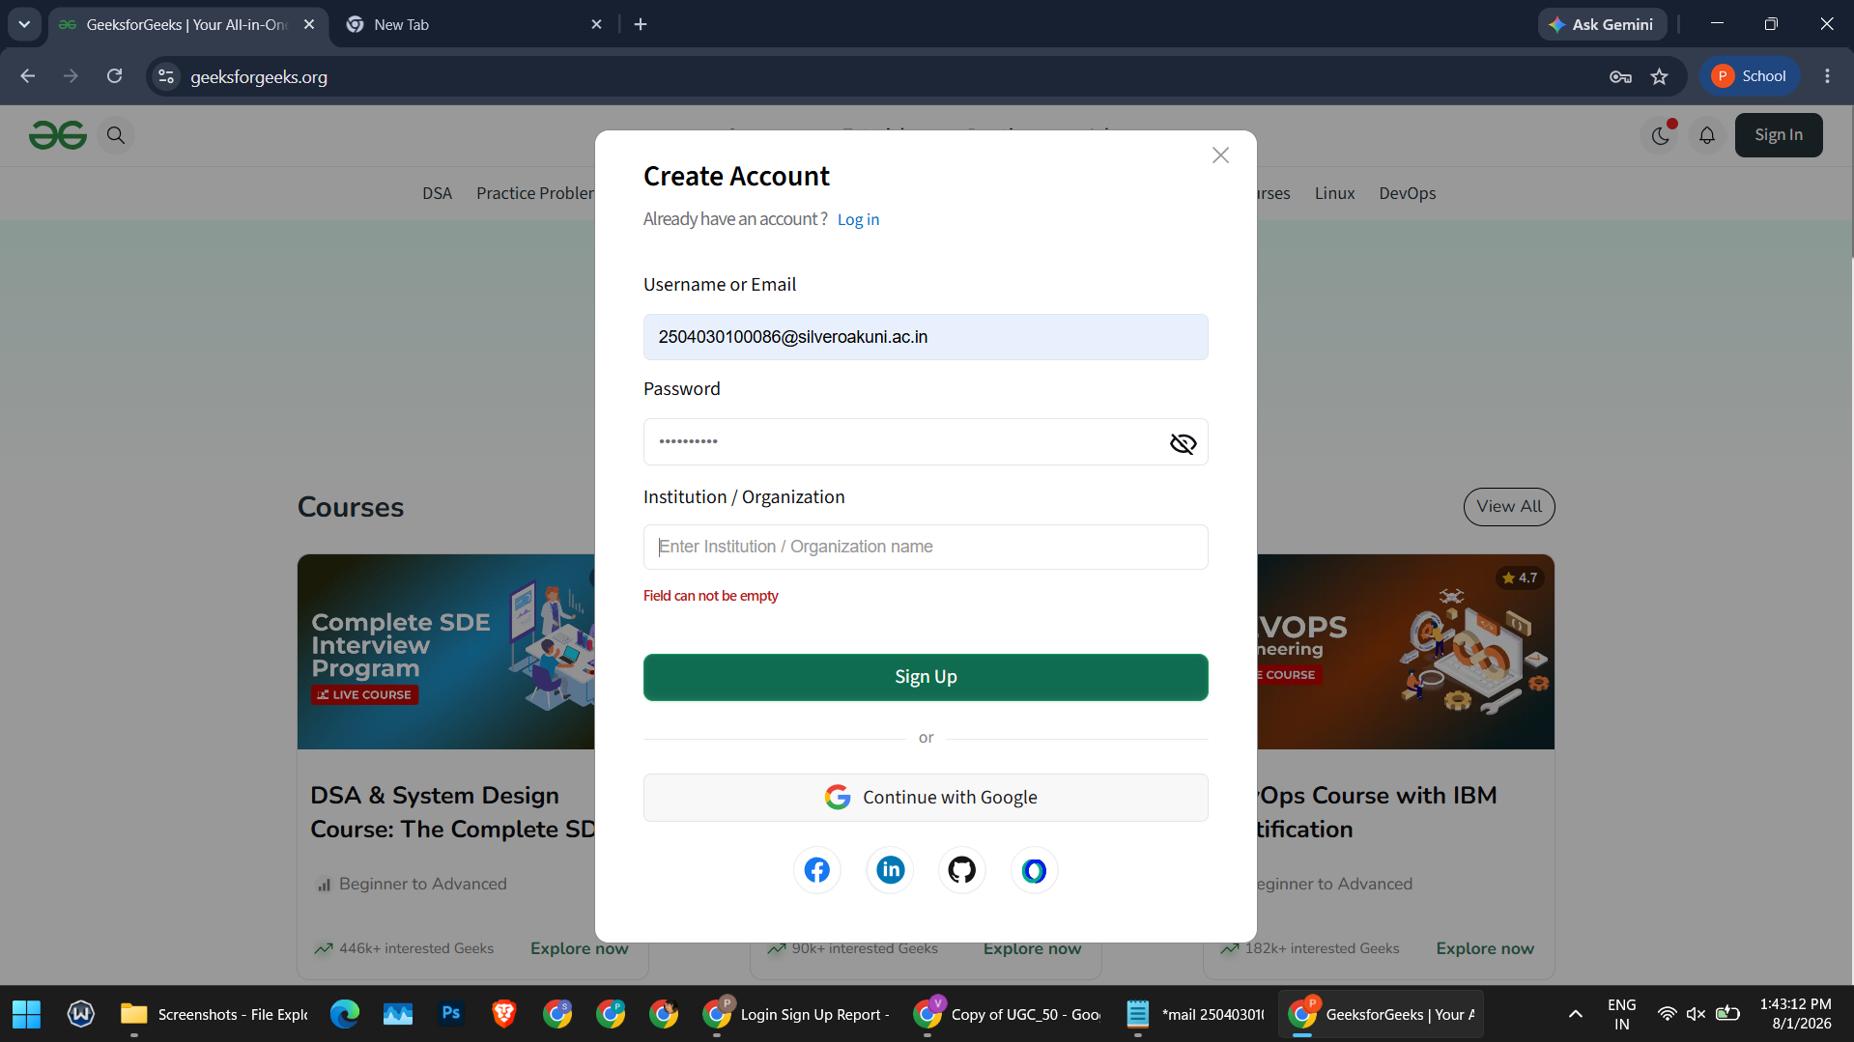
Figure 10. Actual login/verification outcome. Related test: TC019. Status: Pass.
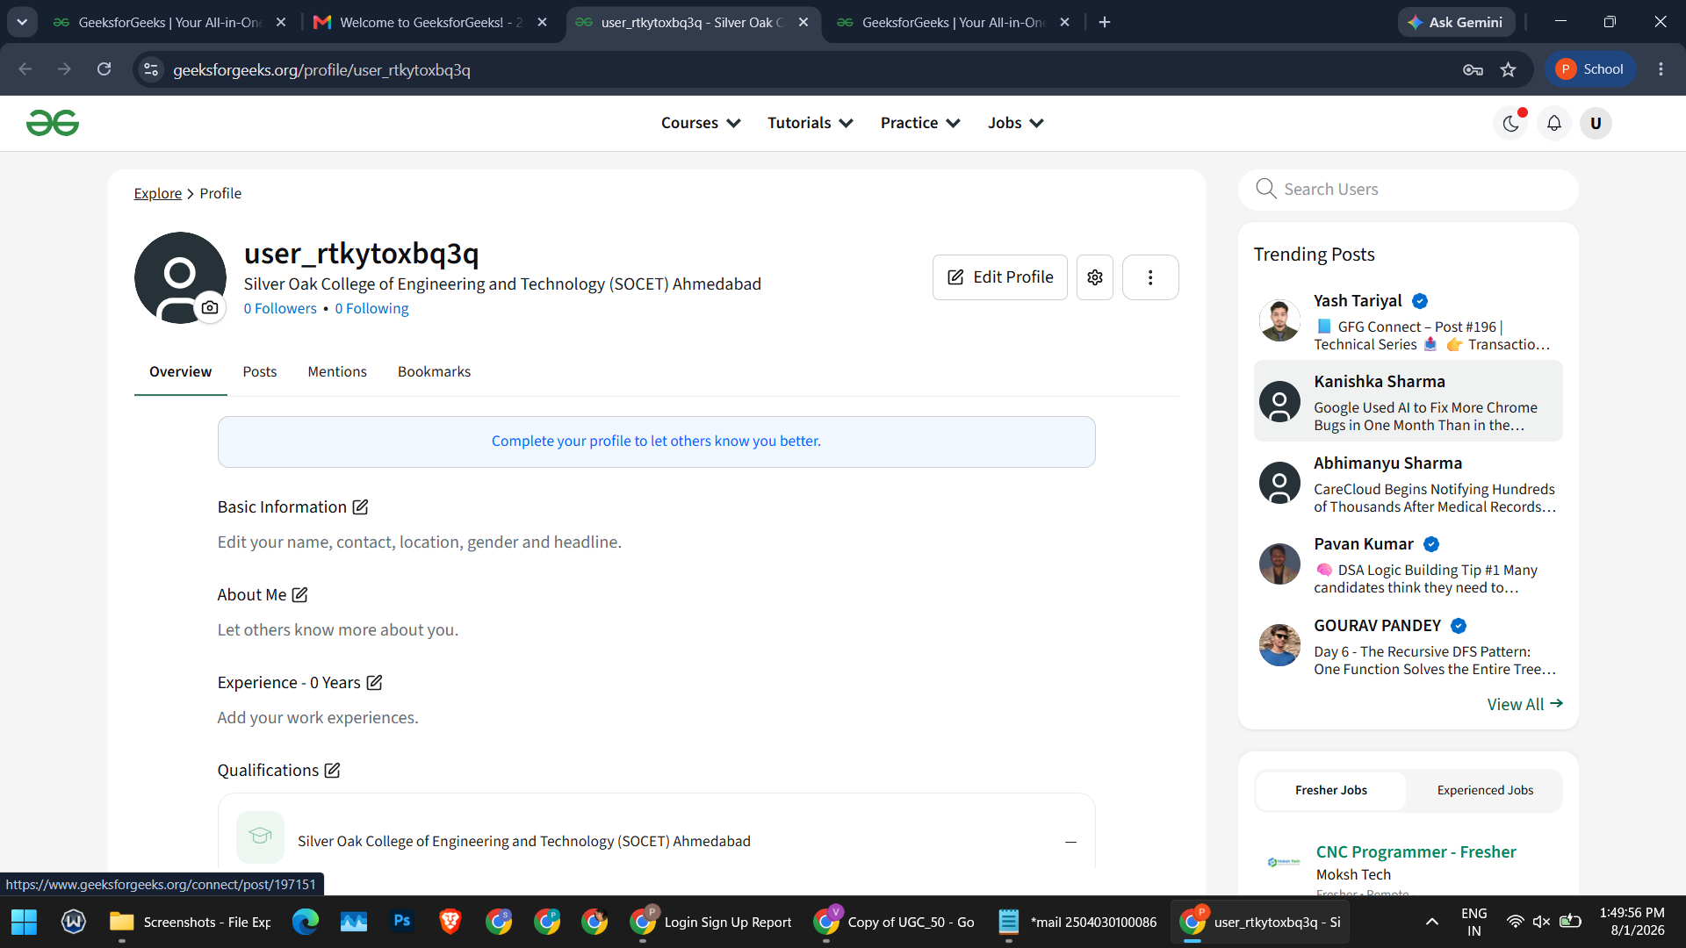
Figure 11. Profile/account page. Related test: TC020. Status: Pass
.

